Week 05 Team assignment

Participants:

* Rob Egbert
* Chris Swearingen

Control Layer UML

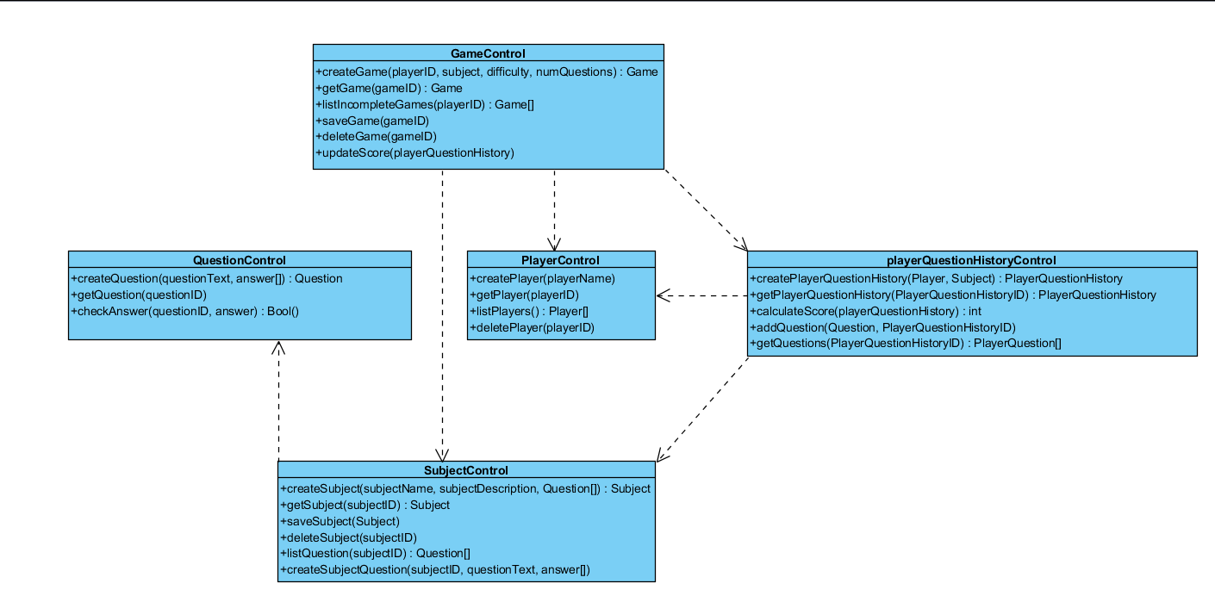

|  |  |  |  |  |  |  |  |  |  |  |  |  |  |  |
| --- | --- | --- | --- | --- | --- | --- | --- | --- | --- | --- | --- | --- | --- | --- |
| calculateQuestionPoints(defaultPoints, questionType, questionTime): int | | | | | | | | | | |  | |  | |
| **calculateQuestionPoints Test Matrix** | | | | | | | | | | |  | |  | |
|  | | | **Default** | | **Valid** |  |  | |  | |  | |  | |
|  | | |  | | 1 | 2 | 3 | | 4 | | 5 | | 6 | |
| **Inputs** | | |  | |  |  |  | |  | |  | |  | |
| **Scenario 1** | | |  | |  |  |  | |  | |  | |  | |
| **points** | | | 5 | | 5 | 5 | 5 | | 5 | | 5 | | 5 | |
| **questionType** | | | 0 | | 0 | 0 | 0 | | 0 | | 0 | | 0 | |
| **questionTime** | | | 0 | | 1 | 2 | 3 | | 4 | | 5 | | 6 | |
|  | | |  | |  |  |  | |  | |  | |  | |
| **Outputs** | | |  | |  |  |  | |  | |  | |  | |
| **points** | | | 5 | | 6 | 7 | 8 | | 9 | | 10 | | 11 | |
|  | | |  | |  |  |  | |  | |  | |  | |
| **Scenario 2** | | |  | |  |  |  | |  | |  | |  | |
| **points** | | | 5 | | 5 | 5 | 5 | | 5 | | 5 | | 5 | |
| **questionType** | | | 0 | | 5 | 5 | 5 | | 5 | | 5 | | 5 | |
| **questionTime** | | | 0 | | 1 | 2 | 3 | | 4 | | 5 | | 6 | |
|  | | |  | |  |  |  | |  | |  | |  | |
| **Outputs** | | |  | |  |  |  | |  | |  | |  | |
| **points** | | | 5 | | 11 | 12 | 13 | | 14 | | 15 | | 16 | |
| **error** | | | success | | success | success | success | | success | | success | | success | |
|  |  |  | |  | | | |  | |  | |  | |
|  |  |  | |  | | | |  | |  | |  | |
|  |  |  | | **Invalid** | | | |  | |  | | **Boundary** | |
| 7 | 8 | 9 | | 10 | | | | 11 | | 12 | | 13 | |
|  |  |  | |  | | | |  | |  | |  | |
|  |  |  | |  | | | |  | |  | |  | |
| 5 | 5 | 5 | | <5 | | | |  | |  | | 5 | |
| 0 | 0 | 0 | |  | | | | !0 or !5 | |  | | > 0; < 5 | |
| 7 | 8 | 9 | |  | | | |  | | < 0 or > 9 | | > 0; < 9 | |
|  |  |  | |  | | | |  | |  | |  | |
|  |  |  | |  | | | |  | |  | |  | |
| 12 | 13 | 14 | |  | | | |  | |  | |  | |
|  |  |  | |  | | | |  | |  | |  | |
|  |  |  | |  | | | |  | |  | |  | |
| 5 | 5 | 5 | |  | | | |  | |  | | 5 | |
| 5 | 5 | 5 | |  | | | |  | |  | | > 0; < 5 | |
| 7 | 8 | 9 | |  | | | |  | |  | | > 0; < 9 | |
|  |  |  | |  | | | |  | |  | |  | |
|  |  |  | |  | | | |  | |  | |  | |
| 17 | 18 | 19 | |  | | | |  | |  | |  | |
| success | success | success | | Invalid question Type or time parameter | | | |  | |  | |  | |

Algorithm

calculateQuestionPoints(defaultPoints, questionType, questionTime): int

BEGIN

IF defaultPoints not equal 5 OR questionType not equal 0 or not equal 5 OR questionTime less than 30 or greater than 120

THEN display error message “Invalid question type or question time parameter”

question.points = defaultPoints + questionType + questionTime;

RETURN points;

END